## *An approach towards Smart Water Measurements through significance of Internet of Things*

**ABSTRACT:**

*A smart water meter is a device that is used for measuring the water consumption by homeowners who have the gadget installed within their establishment. To date, rollouts of smart meters are mostly induced to obtain larger amount of data regarding end-use (such as use by the garden, toilet, shower, etc.) and time of use as well as by the effectiveness of the mechanism to reduce labor costs for a meter reading. So, in this paper, we propose a solution to this serious dilemma, i.e., water conservation, with the help of a smart water metering system whose fundamental purpose is to monitor household water usage and prevent wastage of water with the help of our low-cost IOT based system and various sensors to gather information about water consumption and flow parameters. The purpose regarding this system is considerable with all the parameters such as water conservation, effective water management, developing technologies, etc. The core circuit of the project contains only sensors and the Raspberry Pi, which are of no harm to the environment at all. It will greatly reduce the work of the officials in charge of maintaining the public records manually, as it proved an ideal and trust-worthy solution of using the databases, filled with the information provided by the sensors.*

**KEYWORDS:**

Leakage detection, Flow Rate, Smart Water Meter, Raspberry Pi, Water meter App, Urban Water Management, Water Flow Sensor.

1. **INTRODUCTION:**

A system where physical objects can turn into active participants and services can be connected with these objects using the internet is referred to as IoT (Internet of Things). The system promotes communication and engagement of the devices in a network with other similar devices and with the external environment by exchange of information. This can be done via the internet and may or may not involve human interaction. To measure the quantity of water consumption in a building or household, an internet-dependent mechanism called smart water meter can be adopted.

Nowadays, water conservation is one of the leading issues in multiple households. The initiative should be taken by the apartment association to send the message of the water consumed in quantity by each resident or household to the respective families. In this paper, we proposed the solution for the above issue by installing a smart water meter for every house in the apartment to monitor the water consumption level using IoT technology. Another issue is where a standard meter is fitted in a building complex and the bill for the cumulative consumption amount is shared among the households. As a result, they are charged a price higher than what is within their financial reach. In such cases, a system is required where the charges are levied as per consumption of each family or household rather than a total cumulative consumption.

The solution for this problem lies in the Smart meter for water utilization. It measures the quantity of water consumed by each household and allows monitoring at the consumption level. In further scope, the supply of water can be terminated if the residents are not present in their homes. This allows for fair billing and reduces energy consumption directly and indirectly.

1. **LITERATURE SURVEY:**

This section can be divided into two parts, based on the nature of research papers, government policy documents, etc. that are taken into consideration. First, we will discuss the research work in the field of water management related to IoT.

In the paper ‘IoT Based Automated Water Distribution System with Water Theft Control and Water Purchasing System’ by G. M. Tamilselvan, V. Ashishkumar, S. Jothi Prasath, and S. Mohammed Yusuff,  khe key idea was to plan a cost-proficient framework to accomplish better water supply by regular supervision and control from a central server to eliminate problems in the supply to the habitants. The model thus designed overlooks the overflow, overutilization, water acquirement, and appropriate distribution. This framework proposes the utilization of an Ethernet for wireless correspondence. The main goal is that the data can be exchanged with the individual who is checking the framework directly. Thus, utilization of time and human resources is minimised. The aim is to supply liquid petroleum gas and other fuels through specially designed pipelines based on the guidelines of the proposed work in the future. The system can also be extended to identify the precise location of pressure drop in the water distribution system.

The paper ‘IoT-based model for monitoring and controlling water distribution’ by J G Natividad and T D Palaoag, aims to design and develop a low-cost, reliable, and efficient technique to improve water distribution in the community. The IoT-based model consists of two circuit designs, the Monitoring, and Controlling System. The model makes use of a micro-controller and Web Server for monitoring, relying on a system-on-chip micro-computer. Several sub-parameters are added as input to determine factors such as when to send the report to the server, when to turn on the motor pump to refill the water reservoir and so on. Also, as a control measure, the micro-controller turns off the motor pump while refilling, if it reaches the set maximum level of water. the logic algorithm was implemented in sending the SMS report to the server displaying the status of the water reservoir.

In the paper ‘IOT Based Real-time water Monitoring System for Smart City’ by Rupalir. Shevale, Shweta Karad, Ashwini Kardile, Maryam Merchant, and Vijeyata Mishra, an IoT-based model for water level and quality monitoring, is presented.  Here, the data is collected using sensors and accessed on a real-time basis through the website. The data received from the sensors is processed by a microcontroller and sent to the cloud via a wireless transmission module. The problem statement of this paper is that the existing water treatment systems cannot detect the dissolved contaminants or monitor water quality in terms of pH levels, amount of chlorine and so on. Thus, the project is aimed at curbing water-borne diseases by developing a real-time online water quality monitoring system and detecting, monitoring and improving all the possible water quality parameters, including availability of water in the water tank.

The information collected from these sources brings us to a conclusion as to how the various technologies of IoT are being implemented in the field of water management (monitoring, controlling, theft prevention, distribution, etc.) with the scope of development and improvement in the future.

In the second part, we will discuss the information obtained from the sources concerning the various Government Initiatives Towards the Water Resource Management and Funding Plans of India.

The article ‘Steps taken by the Central Government to control water depletion and promote rainwater harvesting/conservation’, mentions the actions taken by our Honourable Prime Minister and various other Ministries (like Ministry of Jal Shakti) and Departments (like Department of Water Resource, RD&GR) and the policies (such as Watershed Development Component (WDC) and National Water Policy (2012)) implemented by them. The aim is to make the citizens aware of the impact and significance of water harvesting and conservation and motivate them to undertake and adopt appropriate measures for the same. Also, there should be prohibition of encroachment and diversion of water bodies and drainage channels. restoration work should be undertaken wherever it has taken place, to a feasible extent and with adequate maintenance.

The report ‘Composite Water Index Management’ by the NITI Aayog, is an effort by the government to advocate the adoption of the greatest quality of practices in the water sector of the country. The governing body recognizes that data-based decision-making is crucial for effective water management. It reports the progress of various States and Union Territories, determined by a set of comprehensive water management metrics. NITI Aayog (National Institution for Transforming India) contributed heavily to the development of the Composite Water Management Index (CWMI) for efficient water management in Indian states. CWMI 2019 measures the above-mentioned attainment by the various States and addresses relative performance in 2017-18 and its comparison with trends from prior years (2015-16 & 2016-17). It signifies a notable step towards the goal of the management effort in India, leading to the promotion of ‘competitive and collaborative federalism’ in the country's water governance and administration.

The 6th Meeting of the National Water Resources Council (NWRC) was held under the Chairmanship of our former Hon'ble PM Dr. Manmohan Singh, the Chairman, Members of the Council, and other participants. This summary report includes the numerous statements, opinions, emphasis, and suggestions made by the chief ministers, governors, and ministers-in-charge of India's different states. These included the need to incorporate economic incentives, clearances of water projects with sufficient time constraints. Project planning should consist of the 3Es (Engineering, Economics, and Ecology) that enable adoption of a holistic approach towards water conservation. The primary topic of this meeting, National Water Policy (2012), was an effort to focus on the increasingly looming crisis in the water sector and lay a structural map based on the fundamentals of  equality, sustainability, and good governance, for the future.

The Budget Talk 2019 was headed by Finance Minister Nirmala Sitharaman. Views of Raman VR, Head of Policy, WaterAid India, New Delhi, and various coordinators, environmental activists, and development researchers are well-quoted and presented. No explicit allocation was made for the Jal Shakti Abhiyan, which points to a supposition that this mission will be chiefly drawing from budgets for other development programs and thus interfere with development and growth of other sectors. Considering the prevailing water crisis in the country, the government has identified as many as 1,592 blocks in 256 districts facing an acute water crisis, where over-exploitation of groundwater has been reported. The 2019 budget was high on optics, even with a meager allocation and lack of clarity on how the actual delivery would happen.

1. **PROPOSED METHODOLOGY:**
   1. **Smart Water Metering App**
      1. **Software used – Android Studio**

We used Android Studio to develop and deploy our smart water meter app. Android The studio is the official IDE for Android and was designed specifically for Android to help one in building high-quality apps for any Android device. We chose Android studio due to its following features:

a.       It allows you to make resource changes and push code to the running app without rebooting the app.

b.      It has an intelligent code editor that aids in better code writing and offers advanced refactoring, code completion and analysis.

c.       It provides with fast and fully featured emulator.

d.      Android Studio comes with a powerful static analysis system that includes over 365 different lint tests that can be applied to the entire app. It also includes several fast fixes that allow you to resolve issues in a variety of categories with a single click, such as efficiency, protection, and correctness.

e.       At last, it comes with firebase and cloud integration.

* 1. **Smart Water Meter Mechanism**
     1. **Software used - Thonny**

Thonny was used for hardware coding. Though Thonny is designed for beginners, it has several features that make it an excellent IDE for full-fledged Python development. Syntax error highlighting, a debugger, code completion, and step-by-step expression evaluation are only a few of the functions. It comes pre-installed with the new Raspbian with PIXEL operating system.

* + 1. **Hardware used**
       1. **Water Flow Meter:**

Water Flow Sensor YF-S201 sits in line with the waterline and contains a hall effect/ pinwheel sensor to measure the water flowing through it. The integrated hall effect sensor outputs an electric pulse with every revolution. It is sealed from the water pipe which allows the sensor to stay safe and dry.

Three wires are used with the sensor: red (5-24VDC power), black (ground), and yellow (Hall effect pulse output). By counting the pulses from the output of the sensor, the water flow can be easily calculated. Each pulse is approximately 2.25 milliliters. This is not a precision sensor, and the pulse rate does fluctuate a bit depending on the fluid pressure, flow rate, and sensor orientation. This will need precise calibration to attain better than 10% precision.

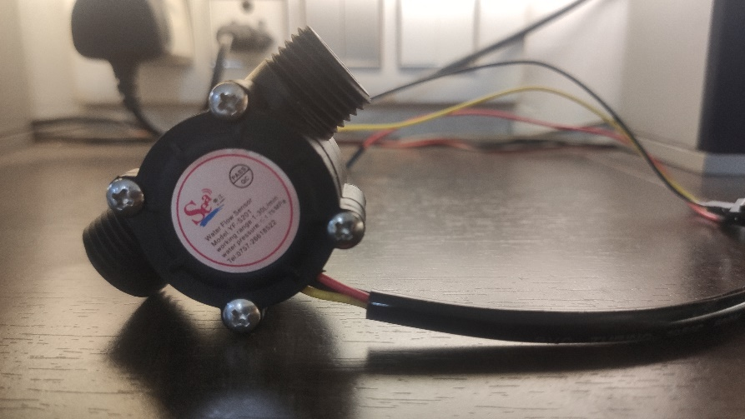

Figure 1: YF-S201 Water Flow Sensor

* + - 1. **Raspberry Pi:**

**The Raspberry Pi 3 is a Python Interpreter series development board. It is a single-board computer that works on LINUX operating system. This not only has a lot of features, but it also has terrific processing speed which makes it best suitable for advanced applications. It is specifically designed to be used for IoT (Internet of Things) based applications. It is an open-source platform where we can get a lot of information therefore, we can customize the system depending on the need. The latest model of Raspberry Pi that is Raspberry Pi 3B+ is a 64-bit quad-core processor, it has an extended 40 pin GPIO header with a micro-SD card slot for loading the operating system, data storage, and application Programs on it. It has a wireless LAN and Bluetooth facility by which we can set up WIFI HOTSPOT for internet connectivity, this feature is best suited for IoT applications. It has several Pin groups consisting of Power Source, Communication Interface, External Interrupts, TWI Interface, SPI Interface, input and Output Pins, and Pulse with Modulation Output Pins. It has a clock frequency of 1.2GHz and works on operating temperature between -40 C to +85C.**

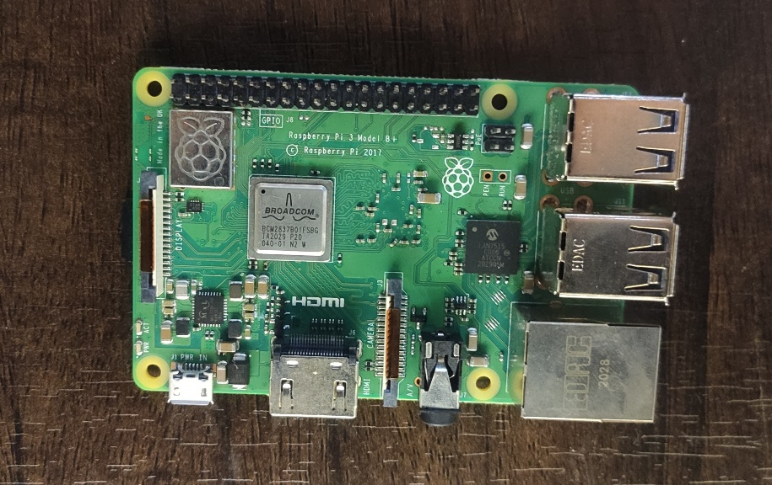

Figure 2: Raspberry Pi 3B+

* + - 1. **OLED Display:**

OLED (Organic light-emitting diodes) is made by arranging a series of organic films between two conductors. A bright light is emitted when a current is applied. They are very thin and efficient and provide the best image quality and can be made transparent and flexible. This is one of the best ways to add a small screen to our IoT-based projects. It has four pins, out of which two are power pins that are VCC and GND and the other two are for the I2C interface SDA and SCL.

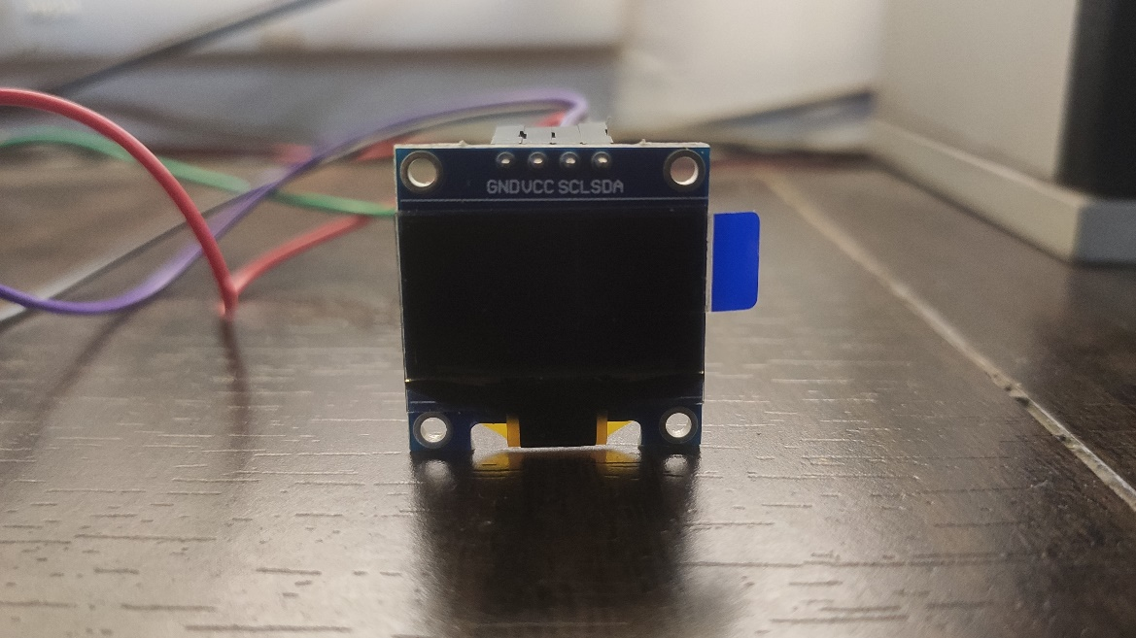

Figure 3: I2C OLED Display Module

* 1. **Connections**
     1. **Microcontroller (****Raspberry Pi) connection with Water Flow Sensor**

The first and basic connection to start with the IoT-based Smart Water Metering system is the connection of the YF-S201 Water Flow Sensor with the microcontroller board Raspberry Pi3 B+. The 3 wires of the flow sensor that are red, black, and yellow are connected to Pin 1 or 17, Pin 4 or 9 or 12 or 18 or 25 or 28 or 32 or 39, and Pin 7 is GPIO04 respectively using male to female jumper wires.

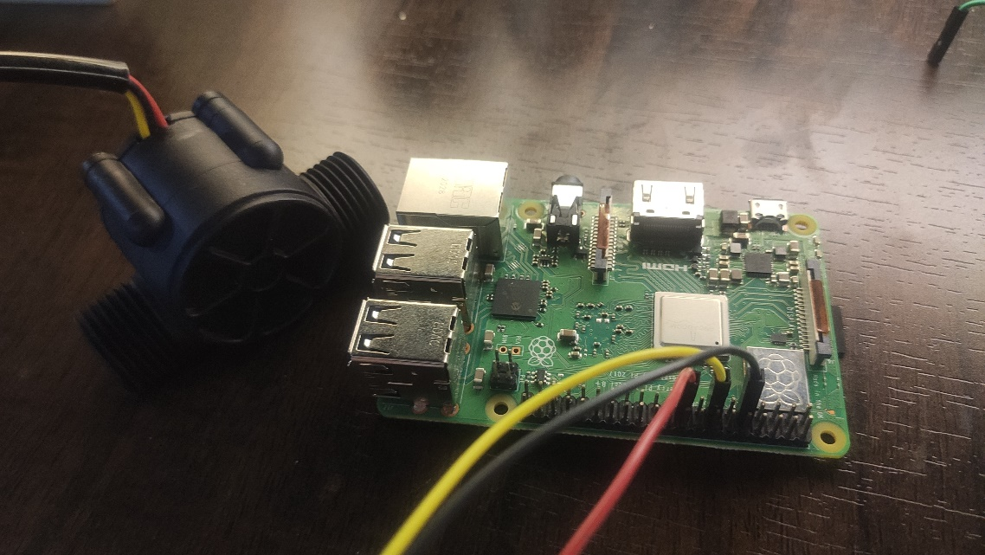

Figure 4: Raspberry Pi connected with Water Flow Sensor

* + 1. **Microcontroller (Raspberry Pi) connection with OLED Display**

Another major connection is to connect the I2C OLED display module with the Raspberry Pi to display the rate and volume measured by the water flow sensor. The 4 major pins of the OLED Display Module are VCC, GND, SDA, and SCL. VCC is connected to Pin 1 or 17, GND to Pin 4 or 9 or 12 or 18 or 25 or 28 or 32 or 39, SDA to Pin 3, and SCL to Pin 5 respectively using female to female jumper wires.

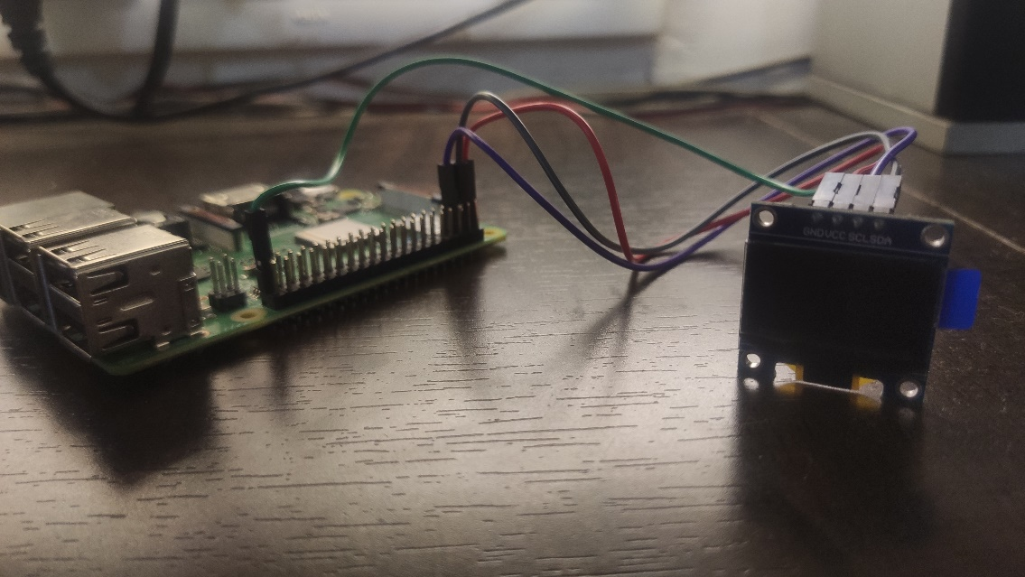

Figure 5: Raspberry Pi connected with OLED Display

* + 1. **Connection of the hardware system with the SWM App**

There are several online services that provide storage, online processing, real-time databases, user authorization, and so on. Firebase, a platform developed by Google provides all these services. It also offers regular analysis of the services used, as well as information about the users who use them.

To put it another way, Firebase is a forum for developing mobile and web applications. It provides services that a web application or mobile application might require.

The purpose of using firebase in our system was to store real-time data about water flow rate and volume along with user’s information (entered via app).

The data from the sensor is synchronized in the firebase real-time database.



FirebaseApplication() serves as a contact hub for all Firebase resources used by a given app. Based on the settings in the Firebase configuration file, a default instance is built automatically, and all of the Firebase APIs bind to it.



We used patch() method to link the sensor reading with firebase. This method updates the value of flow rate and volume with new values on a real-time basis.

The android app (built on Android Studio) was then registered with our firebase project so as to retrieve the data.

Later, the Firebase Android configuration file (google-services.json) was added to our android app. All the data from Firebase Realtime Database is saved as JSON objects. The database is a JSON tree hosted by the cloud. When the data is added to the JSON tree, it becomes a node in the existing JSON structure with an associated key. 00000

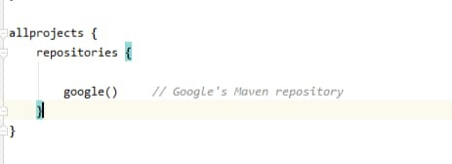

The project’s dependencies are saved in the Maven local repository. Maven automatically installs all the dependency jars into the local repository whenever a Maven build is run. Any time a project is built, it helps to prevent dependencies' references stored on a remote machine.

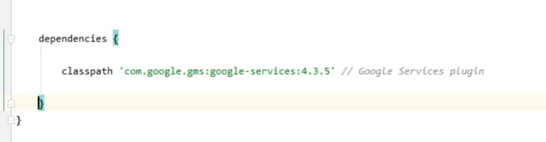

To enable firebase services and Google APIs google-services plugin was added to the build.graddle file. The google-services plugin aids in processing the google-services.json file. Additionally, basic library dependencies required for the enabled services are added via the google-services plugin.

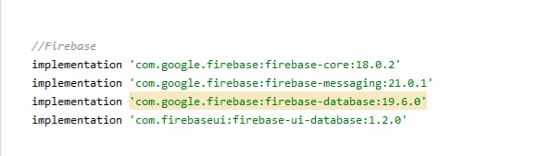

The dependencies were then declared using Firebase Android BoM for the Firebase products that are used in the app.

To ensure that all dependencies acquire the requisite versions, the app had to be synced.

* 1. **Working of Water flow sensor**

The working principle of the water flow sensor is very simple. The major components are hall effect sensor, turbine wheel, and magnet. The water flows from the inlet to the outlet, passing through the turbine wheel. The water force moves the turbine wheel, and the magnet of the wheel turns with it. This causes the magnetic field rotation to trigger the hall effect sensors, causing the high and low square pulses. For every round of the wheel, the volume of water passing through it is a specific amount, as is the number of square waves output.

The water flow rate is determined by a change in the velocity of water that depends on the pressure that forces the turbine to rotate. The pipeline and the inlet-outlet through which the water flows have a constant cross-sectional area and therefore the average velocity is used to indicate the water flow rate. The basic formula used to determine the liquid’s flow rate in such cases can be driven down using the following calculations:

The number of output pulse from the sensor can be used to determine the water flow rate. Approximately each pulse is 2.25mililiter (this may vary according to the fluid pressure and sensor orientation). The sensor outputs around 4.5 pulses for every 1 liter per minute because of the changing magnetic field generated by the magnet placed in the turbine wheel. The specified water flow rate characteristic of water flow sensor YF-S201 is:

Frequency = 6.25 * Flow Rate

Flow Rate = Frequency / 6.25

Volume = Volume + (Flow Rate / 60)

This useful data is stored in CLOUD using the Raspberry Pi. This can also be used to generate bills for the amount of water used. The values of the amount of water passed that is the total volume and rate is passed to the cloud (FIREBASE). So that in case of any destruction of the system or unexpected event of a crash of software the values or data is stored and kept safe on the cloud. Therefore, for security and safety purposes we use the cloud.

* 1. **Experimental Analysis**

The flow sensor used outputs pulses and they vary according to the speed of water passing through. Therefore, it can be observed that:

Flow Rate ∝ Pulse Frequency

F = P/K

Hence, the value of flow rate, F depends on two factors- pulses, P and calibration factor, K.

To determine K: Initially, in a given time, a known amount of water is passed through the sensor. The water rotates the rotor in the sensor and generates pulses. The number of pulses generated in a particular time is recorded. Using the value of pulse frequency and the flow rate a graph is plotted, to determine the K-factor.

To verify K: Water is again passed through the sensor and this time the value of K determined earlier is used to calculate flow rate and volume. The water is collected in a measured container to check if the value matches the sensor reading.

|  |  |  |  |  |  |
| --- | --- | --- | --- | --- | --- |
| Sr. No. | Time (sec) | Volume (Litres) | Pulses per given time | Flowrate (L/min) | Pulses/sec |
| 1. | 20.75 | 3 | 1226 | 8.670 | 59.084 |
| 2. | 26.28 | 4 | 1641 | 9.132 | 62.44 |
| 3. | 26.07 | 3.8 | 1555 | 8.75 | 59.65 |
| 4. | 26.92 | 4.06 | 1665 | 9.05 | 61.86 |

Table 1: Determination of Pulse Frequency and Flow Rate

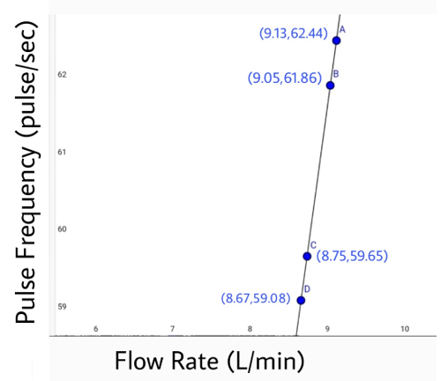

Figure 6: Graph between flow rate and pulse frequency

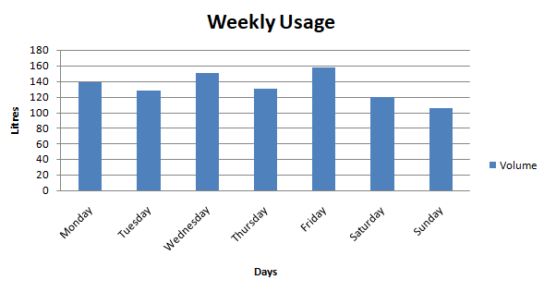

Figure 7: Amount of water consumed weekly

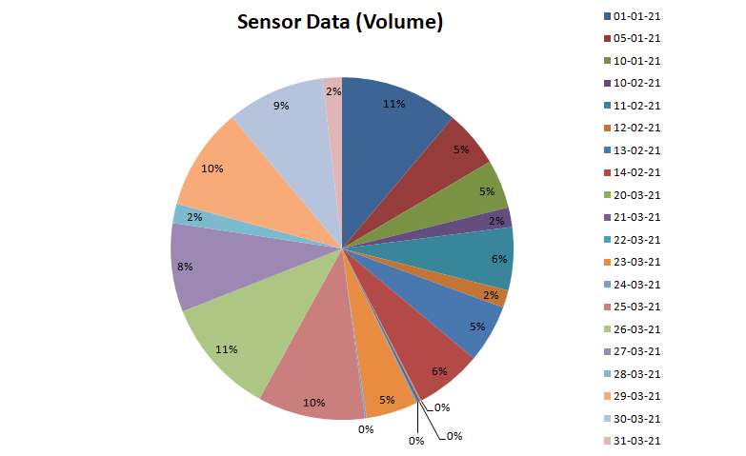

Figure 8: Sensor data measured for different dates.

1. **FURTHER RESEARCH:**

User interface and smart water networks: The idea that the consumers have the ability to view their real-time water consumption on a screen is not far-fetched, especially with the availability of internet (Wi-Fi) in majority of Indian cities and suburbs. This will help consumers distinguish and amend issues (such as leaks) quickly, and thus save water. These interfaces can also be developed into mobile apps.

Network flow and pressure monitoring: Monitoring the water flow in the supply network to measure features such as flow rate and pressure can facilitate water utilities to offer real-time water balance calculations and corresponding bulk flow with consumption data from smart water meters. Therefore, water losses (for instance from leaks) will be promptly identified.

Timely investigation and analysis of suspected incidences of water losses: Water conservation in urban areas can only be actualized if investigations of suspected water losses are facilitated and quickly fixed. Such investigations may be time and labour-intensive.

1. **CONCLUSION:**

To combat the problem of supply and end-use information needs, modern solutions are required. This comes in the form of smart metering, which solves the above problem and also helps fulfil the objective of sustainable urban water management.

Increased and more in-depth detailing, data frequency and accessibility improves the potential to support SWM. Intelligent Metering offers higher resolutions which allow for interpretation of water consumption in terms of end-use, that is, the water consumption measured for a specific activity by a particular appliance. This is critical for the refinement of ‘demand forecasting models’ and pin-pointing opportunities for improving efficiency. While there is improvement in granting greater flexibility, enhanced resolution, and higher frequencies of data collection and communication, there are novel and complicated challenges arising for the water sector, in particular, data management, interpretation, and analysis. The subject of data privacy is also of concern and one that will require the attention of utilities and regulators in the upcoming future.

Another challenge that the industry faces is to encourage the use of smart metering among technology vendors. There lies an apparent instinct for technology vendors to get a hold of a division of the market in this field and further enhance their product. This is achieved through monitoring the effectiveness and user needs based on real-time field analyses. Vendors may see some potential in the future in achieving customer profiles and usage patterns in a technology-driven world.

Consequently, it can be inferred that smart water metering will be a greater and more conspicuous presence in the urban water sector over the subsequent decade. The main obstacle is to assure that its broad-scale introduction does not deter focus from the necessities of both the utilities and customers and that, in the longer time period, the need for public welfare must prevail over shorter-term profits for peddlers of technology and data.

**REFERENCES**